**VISVESVARAYA TECHNOLOGICAL UNIVERSITY**

**“Jnana Sangama”**, **Belagavi, Karnataka– 590 018**

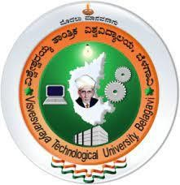

***A***

***Report on***

**INNOVATION / ENTREPRENEURSHIP / SOCIETAL INTERNSHIP**

**(21INT68)**

*Submitted for the partial fulfilment of academic requirements for VI Semester*

**BACHELOR OF ENGINEERING**

**IN**

**ARTIFICIAL INTELLIGENCE AND MACHINE LEARNING**

***Submitted by***

**DISHITHA K S 4CI21AI012**

***Carried out at***

**DLITHE, BENGALURU**

***Under the Internal Guidance of***

**Mr. MURALIDHAR B M**

**Assistant Professor**

**Department of AI&ML**



**DEPARTMENT OF ARTIFICIAL INTELLIGENCE AND MACHINE LEARNING**

**Kodava Education Society®**

**COORG INSTITUTE OF TECHNOLOGY**

(Accredited by NAAC ‘A’ grade, Approved by the AICTE, New Delhi & Affiliated to VTU, Belagavi)  **Ponnampet-571216**

**2023-24**



**Department of Artificial Intelligence and Machine Learning**



**CERTIFICATE**

This is to certify that the course entitled “**Innovation / Entrepreneurship / Societal Internship (21INT68)**” is carried out by **DISHITHA K S (4CI21AI012)** bonafide studentof **Coorg Institute of Technology** in partial fulfilment of internship work for **Bachelor of Engineering** in **Artificial Intelligence and Machine Learning** under **Visvesvaraya Technological University**, **Belagavi** during the academic year **2023-2024**. The report has been verified to satisfy the academic requirements in respect of work prescribed by the university.

|  |  |  |
| --- | --- | --- |
| **----------------------------** | **-------------------------------** | **--------------------------** |
| **Prof. Muralidhar B M**  Internal Guide | **Dr. Ramakrishna B B**  Associate Professor & Head | **Dr. M Basavaraj**  Principal |

**INTERNSHIP CERTIFICATE**

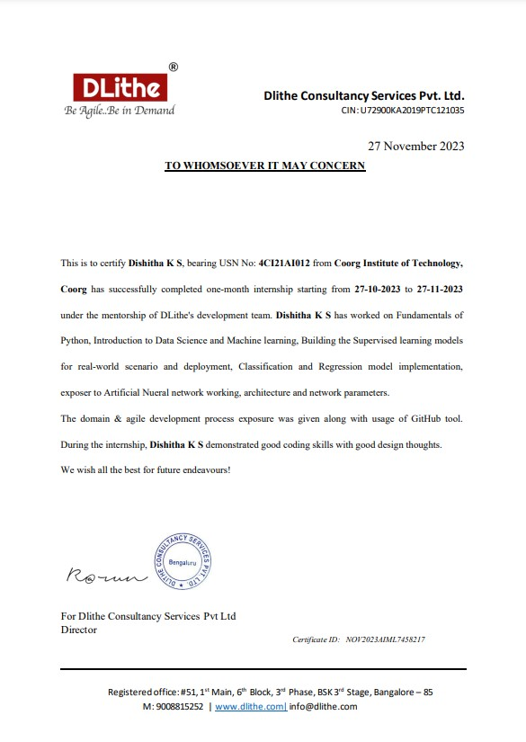

**ACKNOWLEDGEMENTS**

I express my deep sense of gratitude and indebtedness to the management of “***Coorg Institute of Technology***”,Ponnampetwhich provided me an opportunity to fulfil the requirement of completing the internship.

I express my sincere gratitude *to* ***Dr. M Basavaraj****,* ***Principal****,* Coorg Institute of Technology, Ponnampet for his kind-hearted cooperation in the completion of the internship.

I feel elated in expressing my profound sense of gratitude to ***Dr. Ramakrishna B B****,* ***Associate Professor and Head****,* Department of Artificial Intelligence & Machine Learning for his constant encouragement in carrying out the internship.

My profound thanks to ***Prof. Muralidhar B M****,* ***Internal Guide*** and Asst. Professor, Department of Artificial Intelligence & Machine Learning for his constant encouragement and valuable guidance in completion of the internship.

I also thank the company ***DLithe, Bengaluru*** for providing me with this golden opportunity to do the internship which helped me in learning new things.

I would like to thank all the teaching and non-teaching staff members of Department of Artificial Intelligence & Machine Learning for their support and suggestions.

**DISHITHA K S [4CI21AI012]**

**ABSTRACT**

The crop recommendation system powered by machine learning offers a robust framework for aiding farmers in making informed decisions about crop selection. Harnessing the capabilities of advanced algorithms and data analytics, this system analyzes various agronomic factors including soil properties, climate conditions, historical yield data, and crop characteristics. By integrating these diverse datasets, it generates personalized recommendations tailored to the unique needs and constraints of individual farming contexts. Through predictive modeling techniques, the system forecasts the performance of different crops under specific environmental conditions, enabling farmers to optimize their choices for maximum yield and profitability.

Moreover, the crop recommendation system serves as a valuable tool for promoting sustainable agriculture practices. By considering factors such as soil type, soils pH, and temperature, it encourages the adoption of crops that are well-suited to local conditions, thereby minimizing resource wastage and environmental impact. Additionally, by taking into account market trends and demand forecasts, the system assists farmers in aligning their production strategies with market dynamics, enhancing their competitiveness in the agricultural sector. Overall, the crop recommendation system represents a significant advancement in agricultural decision support technology, offering farmers actionable insights to improve productivity, profitability, and sustainability in their farming operations. Its integration of machine learning algorithms holds immense potential for revolutionizing crop management practices and driving innovation in the agricultural industry.

**CONTENTS**

**ACKNOWLEDGEMENTS**

**ABSTRACT i**

## CHAPTER 1 COMPANY PROFILE 01

## CHAPTER 2 ABOUT THE COMPANY 02

## CHAPTER 3 INTRODUCTION 01

## CHAPTER 4 SYSTEM ANALYSIS 01

## CHAPTER 5 REQUIREMENT ANALYSIS 01

## CHAPTER 6 DESIGN ANALYSIS 01

## CHAPTER 7 SNAPSHOTS 01

**CONCLUSION 22**

**BIBILIOGRAPHY 23**

**CHAPTER 1**

**COMPANY PROFILE**

**A Brief History of Company Name**

Company Name, was incorporated with a goal “To provide high quality and optimal Technological Solutions to business requirements of our clients”. Every business is a different and has a unique business model and so are the technological requirements. They understand this and hence the solutions provided to these requirements are different as well. They focus on clients requirements and provide them with tailor made technological solutions.They also understand that Reach of their Product to its targeted market or the automation of the existing

process into e-client and simple process are the key features that our clients desire from Technological Solution they are looking for and these are the features that we focus on while designing the solutions for their clients.

Company Name is a Technology Organization providing solutions for all web design and development, MYSQL, PYTHON Programming, HTML, CSS, ASP.NET and LINQ. Meeting the ever increasing automation requirements, Sarvamoola Software Services. specialize in ERP, Connectivity, SEO Services, Conference Management, effective webpromotion and tailor-made software products, designing solutions best suiting clients requirements.

Company Name, strive to be the front runner in creativity and innovation in software development through their well-researched expertise and establish it as an out of the box software development company in Bangalore, India. As a software development company, they translate this software development expertise into value for their customers through their professional solutions.

They understand that the best desired output can be achieved only by understanding the clients demand better. Varcons Technologies work with their clients and help them to define their exact solution requirement. Sometimes even they wonder that they have completely redefined their solution or new application requirement during the brainstormingsession, and here they position themselves as an IT solutions consulting group comprising of high caliber consultants.

**CHAPTER 2**

**ABOUT THE COMPANY**

Company Name is a Technology Organization providing solutions for all web design and development, MYSQL, PYTHON Programming, HTML, CSS, ASP.NET and LINQ. Meeting the ever increasing automation requirements, Varcons Technologies specialize in ERP, Connectivity, SEO Services, Conference Management, effective webpromotion and tailor made software products, designing solutions best suiting clients requirements. The organization where they have a right mix of professionals as a stakeholders to help us serve our clients with best of our capability and with at par industry standards.They have young, enthusiastic, passionate and creative Professionals to develop technologicalinnovations in the field of Mobile technologies, Web applications as well as Business and Enterprise solution. Motto of our organization is to “Collaborate with our clients to provide them with best Technological solution hence creating Good Present and Better Future for our client which will bring a cascading a positive effect in their business shape as well”. Providing a Complete suite of technical solutions is not just our tag line, it is Our Vision for Our Clients and for Us, we strive hard to achieve it.

**Products of Company**

**Android Apps**

It is the process by which new applications are created for devices running the Android operating system. Applications are usually developed in Java (and/or Kotlin; or other such option) programming language using the Android software development kit (SDK), but other development environments are also available, some such as Kotlin support the exact same Android APIs (and bytecode), while others such as Go have restricted API access.

The Android software development kit includes a comprehensive set of development tools. These include a debugger, libraries, a handset emulator based on QEMU, documentation, sample code, and tutorials. Currently supported development platforms include computers running Linux (any modern desktop Linux distribution), Mac OS X 10.5.8 or later, and Windows 7 or later. As of March 2015, the SDK is not available on Android itself, but software development is possible by using specialized Android applications.

**Web Application**

It is a client–server computer program in which the client (including the user interface and client- side logic) runs in a web browser. Common web applications include web mail, online

retail sales, online auctions, wikis, instant messaging services and many other functions. web applications use web documents written in a standard format such as HTML and JavaScript, which are supported by a variety of web browsers. Web applications can beconsidered as a specific variant of client–server software where the client software isdownloaded to the client machine when visiting the relevant web page, using standardprocedures such as HTTP.

The Client web software updates may happen each time the web page is visited. During the session, the web browser interprets and displays the pages, andacts as the universal client for any web application. The use of web application frameworks can often reduce the number of errors in a program, both by making the code simpler, and by allowing one team to concentrate on the framework while another focuses on a specified usecase. In applications which are exposed to constant hacking attempts on the Internet, security-related problems can be caused

by errors in the program.

Frameworks can also promote the use of best practices such as GET after POST. There are some who view a web application as a two-tier architecture. This can be a “smart” client that performs all the work and queries a “dumb” server, or a “dumb” client that relies on a “smart” server. The client would handle the presentation tier, the server would have the database (storage tier), and the business logic (application tier) would be on one of them or on both. While this increases the scalability of the applications and separates the display and the database, it still doesn’t allow for true specialization of layers, so most applications will outgrow this model. An emerging strategy for application software companies is to provide web access to software previously distributed as local applications. Depending on the type of application, it may require the development of an entirely different browser-based interface, or merely adapting an existing application to use different presentation technology. These programs allow the user to pay a monthly or yearly fee for use of a software application without having to install it on a local hard drive. A company which follows this strategy is known as an application service provider (ASP), and ASPs are currently receiving much attention in the software industry.

Security breaches on these kinds of applications are a major concern because it can involve both enterprise information and private customer data. Protecting these assets is an important

part of any web application and there are some key operational areas that must be included in the development process. This includes processes for authentication, authorization, asset handling, input, and logging and auditing. Building security into the applications from the beginning can be more effective and less disruptive in the long run.

**Web design**

It is encompasses many different skills and disciplines in the production and maintenance of websites. The different areas of web design include web graphic design; interface design; authoring, including standardized code and proprietary software; user experience design; and

search engine optimization. The term web design is normally used to describe the design process relating to the front-end (client side) design of a website including writing mark up. Web design partially overlaps web engineering in the broader scope of web development. Web designers are expected to have an awareness of usability and if their role involves creating mark up then they are also expected to be up to date with web accessibility guidelines. Web design partially overlaps web engineering in the broader scope of web development.

**Departments and services offered**

Company Name plays an essential role as an institute, the level of education, development of student’s skills are based on their trainers. If you do not have a good mentor then you may lag in many things from others and that is why we at Compsoft Technologies gives you the facility of skilled employees so that you do not feel unsecured aboutthe academics. Personality development and academic status are some of those things which lie on mentor’s hands. If you are trained well then you can do well in your future and knowing its importance of Compsoft Technologies always tries to give you the best.

They have a great team of skilled mentors who are always ready to direct their trainees in the best possible way they can and to ensure the skills of mentors we held many skill development programs as well so that each and every mentor can develop their own skills with the demands of the companies so that they can prepare a complete packaged trainee.

**Services provided by the Company**

• Core Java and Advanced Java

• Web services and development

• UI/UX Designs for Independent Sites

• Dot Net Framework

• Python

• Selenium Testing

• Conference / Event Management Service

• Academic Project Guidance

• On The Job Training

• Software Training

**CHAPTER 3**

**INTRODUCTION**

**Introduction to UIUX Design**

User Interface (UI) and User Experience (UX) design are pivotal components in the development of digital products and services. They play a crucial role in ensuring that technology not only functions effectively but also provides a seamless and enjoyable experience for users. This introduction aims to provide an overview of UI/UX design, its significance, and its relevance in the modern digital landscape, setting the stage for the internship report that follows.

**1. Definition of UI/UX Design:**

UI design refers to the creation of the visual elements that users interact with in a digital interface. It encompasses the layout, aesthetics, and overall look and feel of a product or website. On the other hand, UX design focuses on the user's journey and overall experience while using the product. It involves understanding user needs, conducting research, and designing interfaces that are intuitive, efficient, and enjoyable to use.

**2. Significance of UI/UX Design:**

Effective UI/UX design is crucial for several reasons:

- Enhanced User Satisfaction: A well-designed user interface and experience lead to increased user satisfaction, higher user retention, and positive word-of-mouth recommendations.

- Improved Efficiency :Intuitive design can make complex tasks easier to complete, reducing user frustration and boosting productivity.

- Competitive Advantage: In a crowded digital market, superior UI/UX design can set a product apart from competitors and attract a loyal user base.

- Cost Savings: Proper UI/UX design reduces the need for extensive post-launch fixes and updates, saving time and resources.

- User-Centered Approach :UI/UX design focuses on the needs and preferences of users, ensuring that products meet their expectations and requirements.

**3. Evolution of UI/UX Design:**

UI/UX design has evolved significantly over the years. In the early days of computing, interfaces were often text-based and lacked visual appeal. With the advent of graphical user interfaces (GUIs), design became a more prominent consideration. Today, with the proliferation of smartphones and web applications, UI/UX design has become a critical aspect of software development, impacting everything from mobile apps and websites to smart devices and virtual reality experiences.

**4. Challenges and Opportunities:**

While UI/UX design offers numerous benefits, it also presents challenges. The rapid pace of technological change means designers must stay updated with the latest trends and technologies. Moreover, catering to diverse user demographics and preferences can be complex.

However, these challenges also bring opportunities for those entering the field of UI/UX design. Internships provide an excellent platform to gain hands-on experience, tackle real-world design problems, and develop a deep understanding of the principles and practices that underpin effective UI/UX design.

In conclusion, UI/UX design is a dynamic and essential field in the realm of technology and digital product development. This report will delve deeper into the various aspects of UI/UX design, including methodologies, best practices, and case studies, as well as providing insights into the practical experiences gained during the internship. By the end of this report, it is hoped that the reader will have a comprehensive understanding of the importance of UI/UX design and the valuable role it plays in shaping the digital experiences of users.

**PROBLEM STATEMENT AS MENTIONED IN THE PROPOSAL**

**ONLINE ECOMMERCESTORE – FIGMA DESIGN**

**OVERVIEW:**

We are thrilled to have you on board for a hands-on experience in crafting an immersive and user-friendly design for an online Ecommerce Design Store using Figma. This project is an opportunity for you to showcase your creativity, problem-solving skills, and learn the ins and outs of designing for an Ecommerce platform

GOALS:

1. User-Centric Design

2. Visual Appeal

3. Responsive design

4. Collaboration with Development team

KEY TASKS:

1. Research and Analysis

2. Information Architecture

3. Wireframing

4. Visual design

5. Prototyping

**CHAPTER 4**

**SYSTEM ANALYSIS**

**1. Existing System**

Includes different tasks such as “identify candidate solution, analyze candidate solution, compare candidate solution, update the project plan and recommend a system solution.” (Whitten, n.d., p.194). It is system analyst’s duty to facilitate identifying candidate solution task. Normally analysts will identify each of the problems and find appropriate solutions for the problem. As mentioned earlier, documentation of the problem must be done very carefully.

**2. Proposed System**

Figma is a collaborative design tool that facilitates system analysis through its features. It allows multiple users to work on a design simultaneously, promoting real-time collaboration and efficient communication within design teams. Figma supports the creation of design prototypes, user interfaces, and interactive experiences, streamlining the entire design process

**3. Objective of the System**

Defining user requirements, proposing efficient solutions, and ensuring alignment with organizational goals. The objectives of system analysis include understanding and documenting current systems, identifying areas for improvement

**CHAPTER 5**

**REQUIREMENT ANALYSIS**

1. User Needs: Identify the specific needs of users, such as designers, developers, and stakeholders, and ensure Figma meets those requirements.

2. Collaboration Requirements: Analyze how teams will collaborate using Figma, including real time editing, commenting, and version control.

3. Integration Needs: Consider integrating Figma with other tools or platforms to streamline workflows, such as developer handoff tools or project management systems.

4. Security and Access Control: Assess security requirements, including user access levels.

5. Design Workflow: Map out the design workflow from ideation to final designs, ensuring Figma supports each stage efficiently.

6. Prototyping and Interactivity: Evaluate Figma's capabilities for creating interactive prototypes.

7. File Organization: Define a clear structure for organizing Figma files and components to facilitate collaboration and version control.

8. Responsive Design: Ensure Figma supports responsive design considerations for various screen sizes and devices.

9. Feedback Mechanisms: Establish mechanisms for collecting and incorporating feedback.

**CHAPTER 6**

**DESIGN ANALYSIS**

1. Project Scope:

- Clearly define the purpose, goals, and target audience of your design project. - Identify key features and functionalities needed.

2. Wireframing:

- Start with low-fidelity wireframes to outline the basic structure and layout of your design. - Use Figma's frame tool to create different screens or pages.

3. Design Elements:

- Utilize Figma's design tools to create and customize UI elements (buttons, forms, icons, etc.). - Maintain consistency in colors, fonts, and spacing for a cohesive design.

4. Prototyping:

- Link frames to create interactive prototypes that demonstrate user flow and functionality. - Test the prototype to identify any usability issues or improvements needed.

5. Collaboration:

- Leverage Figma's collaboration features to work simultaneously with team members. - Use comments and annotations to provide feedback and discuss design decisions.

6. Responsive Design:

- Ensure your design is responsive by considering various screen sizes and devices. - Use Figma's responsive design features to adapt layouts accordingly.

7. Design System:

- Create a design system to maintain consistency throughout the project.

- Define shared styles and components for efficient design updates.

8. Version Control:

- Take advantage of Figma's version history to track changes and revert to previous versions if needed.

- Maintain organized files and naming conventions for clarity.

9. User Testing:

- Conduct user testing using Figma prototypes to gather feedback.

- Iterate on your design based on user insights and refine accordingly.

10. Export Assets:

- Use Figma to export design assets for development.

- Ensure developers have access to design specifications, including dimensions and styles.

**CHAPTER 7**

**Feedback on Work**

Figma is widely praised for its collaborative design features, real-time editing, and cloud-based platform, making it a popular choice for teams. Users appreciate its versatility, allowing seamless collaboration on UI/UX designs. Some note a learning curve, but once mastered, Figma proves efficient for both small and large design projects. Figma is widely praised for its collaborative design features, real-time editing, and platform-independent accessibility. Users appreciate its cloud-based approach, making design work more seamless across teams. Some may find its pricing a bit high, but overall, it's considered a powerful tool for UI/UX design collaboration. Figma is widely praised for its collaborative design features, real-time editing, and cloud-based accessibility. Users appreciate its versatility in creating UI/UX designs, prototypes, and wireframes. Some find the learning curve minimal compared to other design tools. However, occasional lags in performance and the subscription pricing model may be concerns for some users. Overall, it remains a popular choice for design teams due to its collaborative capabilities

**CHAPTER 8**

**SNAPSHOTS**

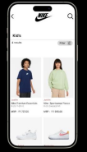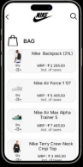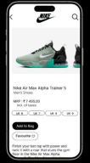

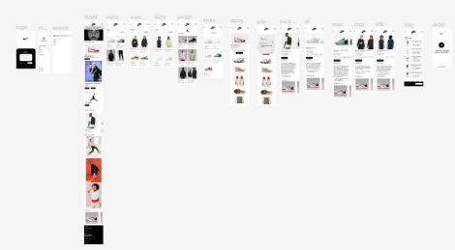

**CONCLUSION**

The package was designed in such a way that future modifications can be done easily. The following conclusions can be deduced from the development of the project:

❖ Automation of the entire system improves the efficiency

❖ It provides a friendly graphical user interface which proves to be better when compared to the existing system.

❖ It gives appropriate access to the authorized users depending on their permissions. ❖ It effectively overcomes the delay in communications.

❖ Updating of information becomes so easier

❖ System security, data security and reliability are the striking features.

❖ The System has adequate scope for modification in future if it is necessary.

**BIBILIOGRAHY**

**1. Figma Official Documentation: [Figma Documentation](<https://www.figma.com/learn/>)**

**2. Figma Community: [Figma Community](<https://www.figma.com/community/>)**

**3. Figma Plugins: [Figma Plugins](<https://www.figma.com/community/plugins/>)**

**4. Figma Blog: [Figma Blog](https://www.figma.com/blog/)**

**5. Figma YouTube Channel: [Figma on**

**YouTube](**[**https://www.youtube.com/c/Figmadesign**](https://www.youtube.com/c/Figmadesign)